<!DOCTYPE html>

<html lang="en">

<head>

    <meta charset="UTF-8">

    <meta http-equiv="X-UA-Compatible" content="IE=edge">

    <meta name="viewport" content="width=device-width, initial-scale=1.0">

    <title>Java Script Tutorial</title>

    <!-- one way to write the java script -->

    <script>

        function myfunction()

        {

            document.getElementById("demo").innerHTML="Hello I am Sanskruti";

        }

    </script>

</head>

<body>

    <div class="container">

        <div class="row">

            This is row in container

        </div>

    </div>

    <p id="demo">Paragraph</p>

    <!-- calling the function from script -->

    <button type="button" onclick="myfunction()">Click Me</button>

    <!-- for javascritp -- prinintg tab -->

    <button onclick="window.print()">Print</button>

    <!-- Write your Java Script her orr write in head part -->

    <script>

        console.log("hello world");

        // for the windows alert

        window.alert("hello")

        // alert(10+2);

    </script>

</body>

</html>

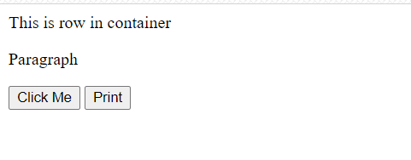

**************************************************************************

<!DOCTYPE html>

<html lang="en">

<head>

    <meta charset="UTF-8">

    <meta http-equiv="X-UA-Compatible" content="IE=edge">

    <meta name="viewport" content="width=device-width, initial-scale=1.0">

    <title>Js - Variables Operators data types </title>

    <script>

        // creating variables in Js

        var a = 12;

        var b = "sanskruti";

        // output in debugging console under inspect

        console.log(a);

        console.log(b);

        c = 34.5;

        // operators in java script

        // in 3+4 ---- + is the operatorr and 3,4 are the operands

        // 1] unary operator  -- it has single operand  (x = - x)

        c = - c;

        console.log(c);       // -34.5

        // 2] binary operator --  it has two opernad   (x = x+6)

        c = 456+6;

        console.log(c);

        // string concatination in Js

        var num1 = 2;

        var num2 = 8;

        console.log("The value of num1 + num2 is " + (num1 + num2));

        // exponential operator

        console.log("The value of num1 ** num2 is " + (num1 ** num2));

        // increment and decrement operator

        console.log("The value of num1++  is " + (num1++));

        console.log("The value of num1 after incrementing is " + (num1));

        console.log("The value of ++num1 is " + (++num1));

    </script>

</head>

<body>

    <div class="container">

        <h1>This is heading</h1>

        <p>Lorem ipsum dolor sit amet consectetur, adipisicing elit. Cupiditate repellendus tempore dignissimos nemo

            reiciendis vel placeat numquam exercitationem a blanditiis?Lorem ipsum dolor sit amet consectetur,

            adipisicing elit. Voluptatem facere id accusamus eaque magnam, voluptates temporibus ad fuga quaerat

            perspiciatis?</p>

    </div>

</body>

</html>

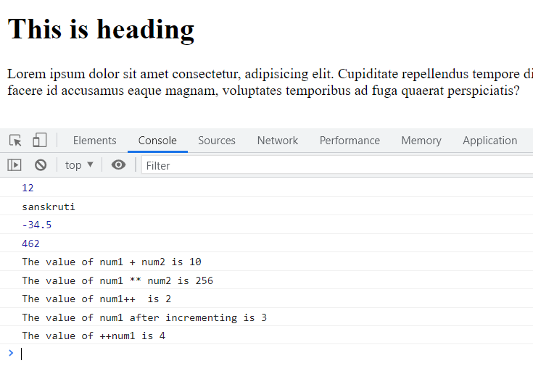

*******************************************************************************

<!DOCTYPE html>

<html lang="en">

<head>

    <meta charset="UTF-8">

    <meta http-equiv="X-UA-Compatible" content="IE=edge">

    <meta name="viewport" content="width=device-width, initial-scale=1.0">

    <title>Strings Js</title>

</head>

<body>

    <div class="container">

        <h1>Lorem ipsum dolor sit, amet consectetur.</h1>

        <h2 id="content"></h2>

        <p>Lorem ipsum, dolor sit amet consectetur adipisicing elit. Repellat deleniti voluptas delectus perspiciatis,

            iste molestias quam eveniet, ducimus, nulla reiciendis eos velit? Cumque beatae voluptate fugit veritatis

            ipsa eius quia!

        </p>

    </div>

    <script>

        var string = "this";

        var name = "Sanskruti"

        var message = "good girl";

        var temp = `Her name is ${name} and she is a ${message}`;    //   ---> `` quotes

        console.log(temp);

        // console.log(string + message);

        var len = name.length;

        console.log(`Length of string name is ${len}`);

        // escape sequence charachter ---> \n , \t, \b, \\

        console.log("\\ hello \n world \\");

        document.getElementById("content").innerHTML="<h2> Hello <\h2>";

    </script>

</body>

</html>

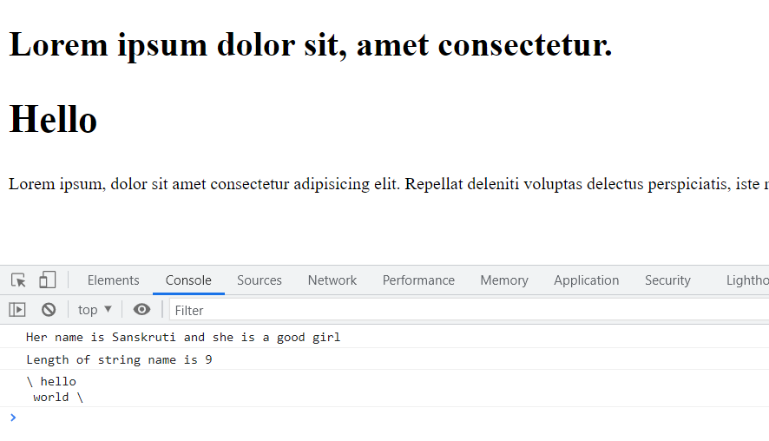

<!DOCTYPE html>

<html lang="en">

<head>

    <meta charset="UTF-8">

    <meta http-equiv="X-UA-Compatible" content="IE=edge">

    <meta name="viewport" content="width=device-width, initial-scale=1.0">

    <title>String Functions</title>

</head>

<body>

    <script>

        var str = "This is a position.";

        console.log(str);

        // first occurance

        var position = str.indexOf("po");            // to find index or the position of any word in string

        console.log(position);

        // last occurance

        var pos = str.lastIndexOf("is");

        console.log(pos);

        // particulaar charachter at an index

        var char = str.charAt(2);

        // var char = str.charCodeAt(2);

        console.log(char);

        //substring from a string

        // var substr = str.slice(1,6);     // printing from index (1 to 5) th position

        var substr = str.substring(1,6);

        console.log(substr);

        // (konse index se chalu karna,  no of charachter to print)

        var substr1 = str.substr(1,6);    // this extract the characters of the length given (1 to 6) postion

        console.log(substr1);

        var replaced = str.replace('position', 'Hello');  //(to be replaced, after replacing )

        console.log(str);                     // old string will not be changed

        console.log(replaced);

        // convert to uppercase  and lowercase charachter

        console.log(str.toUpperCase());

        console.log(str.toLowerCase());

        // concate method or +

        var concated = str.concat("new string");

        console.log(concated);

        // removing the white spaces

        var newStr = "    this contains     lot of white spaces   ";

        console.log(newStr);

        console.log(newStr.trim());   // remove white spaces from front and end

    </script>

</body>

</html>

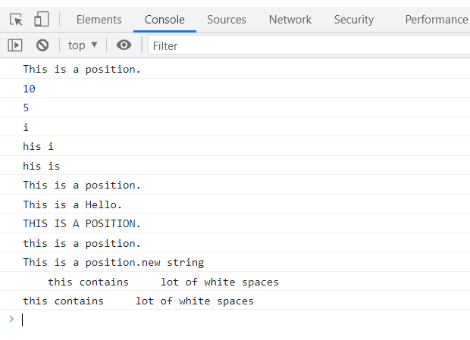

<!DOCTYPE html>

<html lang="en">

<head>

    <meta charset="UTF-8">

    <meta http-equiv="X-UA-Compatible" content="IE=edge">

    <meta name="viewport" content="width=device-width, initial-scale=1.0">

    <title>Scope, If-Else Switch-Case</title>

</head>

<body>

    <!--     div>ul>li{Item-$}*7       -->

    <div>

        <ul>

            <li>Item-1</li>

            <li>Item-2</li>

            <li>Item-3</li>

            <li>Item-4</li>

            <li>Item-5</li>

            <li>Item-6</li>

            <li>Item-7</li>

        </ul>

    </div>

    <script>

        // SCOPE *****************************************************************************

        var string1 = "This is a string1";

        var string1 = "This is a string2"      // var -- it can easily be changed

        console.log(string1);

        // USE let

        let a = "u";           // global scope -- variable -- its value (a) cannot be changed

        // let a = "u6";    ---- it will cause an error

        // block

        {

            let a = "u6";          // local variable  ----now it wont cause error

            console.log(a);   // OUTPUT --> u6

        }

        console.log(a);       // OUTPUT --> u

        // USE const

        const b = "This cannot be changed";

        // b = "no i want to change this";       -- will throw an error

        console.log(b);

        //  *********************************************************************************

        // Conditional

        let age = 34;

        if(age>18){

            console.log("You can drink water");

        }

        else if(age==2){

            console.log("Age is 2")

        }

        else if(age==5){

            console.log("Age is 5")

        }

        else{

            console.log("You can drink Cold Drink");

        }

        // SWITCH-CASE ******************************************************************************

        const cups = 47;

        switch (cups)

        {

        case 4:

            console.log("The value of cups is 4")

            break;

        case 41:

            console.log("The value of cups is 41")

            break;

        case 42:

            console.log("The value of cups is 42")

            break;

        case 43:

            console.log("The value of cups is 43")

            break;

        default:

            console.log("The value of cups is none of 4, 41, 42, 43")

            break;

        }

    </script>

</body>

</html>

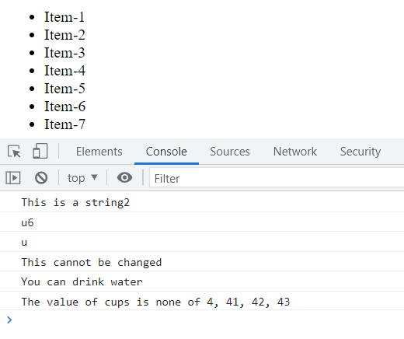

<!DOCTYPE html>

<html lang="en">

<head>

    <meta charset="UTF-8">

    <meta http-equiv="X-UA-Compatible" content="IE=edge">

    <meta name="viewport" content="width=device-width, initial-scale=1.0">

    <title>Arrays and Objects</title>

</head>

<body>

    <div class="container">Simple si html</div>

    <script>

        let myvar1 = 28;

        let myvar2 = "sanskruti";

        let myvar3 = true;           // boolean

        let myvar4 = null;

        let myvar5 = undefined;     // default value of any unassigned variable is -- undefined (ex-- let var;)

        // object

        let employee = {

            name : "sanskruti",

            age : 20,

            channel : "do your best",

        }

        console.log(employee);

        //  two ways to access its values---- 1] obj.key    2] obj['key']

        console.log(employee.age);     // we can ask for specific key and values

        console.log(employee.name);   // or ---- employee['name']

        // Arrays

        let values = [2, 2.5, "sanskruti"];

        console.log(values);

        console.log(values[2]);          // values at specific indexes

        console.log(values[0]);

        //  array -- object using -- new keyword

        //  to create an array of size n -----> let var = new Array(n);

        let obj = new Array(2, 4, 2.5, undefined, 8, "sanskruti");

        console.log(obj[2]);

        console.log(obj.length)

        obj = obj.sort();

        obj.push("This is pushed!");

        console.log(obj);

    </script>

</body>

</html>

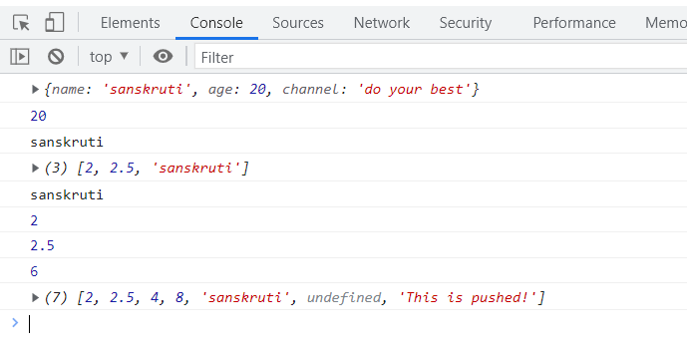

<!DOCTYPE html>

<html lang="en">

<head>

    <meta charset="UTF-8">

    <meta http-equiv="X-UA-Compatible" content="IE=edge">

    <meta name="viewport" content="width=device-width, initial-scale=1.0">

    <title>Interaction - Alert, Prompt, Confirm</title>

</head>

<body>

    <div class="container">This is a page </div>

    <script>

        // Alert in in-browser javascript  ---> dont return anything

        alert("this is a message");

        // if we want to ask something from user ---- prompt(message, default argument)

        // let name = prompt("What is your name?"); -- this is also correct

        let name = prompt("What is your name?", "Guest");

        // Confirm  --- warining to user

        let deletepost = confirm("Do you really want to delete this?");

        // ok -- return true     cancel -- false

        console.log(deletepost);

        if(deletepost)

        {

            console.log("Post deleted");

        }

        else{

            console.log("Post not deleted");

        }

    </script>

</body>

</html>

<!DOCTYPE html>

<html lang="en">

<head>

    <meta charset="UTF-8">

    <meta name="viewport" content="width=device-width, initial-scale=1.0">

    <meta http-equiv="X-UA-Compatible" content="ie=edge">

    <title>Loops</title>

</head>

<body>

    <div class="container">

        This is about loops

    </div>

    <script>

    console.log("This is tutorial 55");

    // let i = 0;

    // for(i=0; i<3;i++){

    //     console.log(i);

    // }

    let friends = ["Rohan", "Sanjeev", "Deepti", "Pooja", "SkillF"];

    // for (let index = 0; index < friends.length; index++) {

    //     console.log("Hello friend, " + friends[index]);

    // }

    friends.forEach(function f(element){

        console.log("Hello Friend, " + element + " to modern JavaScript");

    });

    for (element of friends){

        console.log("Hello Friend, " + element + " to modern JavaScript again");

    }

    let employee = {

        name: "Harry",

        salary: 2,

        channel: "CWH"

    }

    // Use this loop to iterate over objects in JavaScript

    for(key in employee){

        console.log(`The ${key} of employee is ${employee[key]}`);

    }

    //******************************************************************************

    // while loop in js

    let i =0;

    while(i<4){

        console.log(`${i} is less than 4`);

        i++;

    }

    // do while loop in js

    let j =34;

    do{

        console.log(`${j} is less than 4 and we are inside do while loop`);

        j++;

    }while(j<4);

    </script>

</body>

</html>

Navigation DOM

<!DOCTYPE html>

<html lang="en">

<head>

    <meta charset="UTF-8">

    <meta http-equiv="X-UA-Compatible" content="IE=edge">

    <meta name="viewport" content="width=device-width, initial-scale=1.0">

    <title>Manupulating DOM</title>

    <!-- DOM -- doccument object model -->

</head>

<body>

    <div class="container" id="main">

        <ul id="nav">

            <li>Home</li>

            <li>About Us</li>

            <li>Info</li>

            <li>Contsct Us</li>

        </ul>

    </div>

    <div class="container">This is a container</div>

    <script>

        let main = document.getElementById('main');

        console.log(main);       // now i am able to access element whose id is main in console

        console.log(main.innerHTML);

        let containers = document.getElementsByClassName('container');

        console.log(containers);

        // we can access each container by --- containers[index]

        let sel = document.querySelector('.container');

        console.log("Selector returns ", sel);

        let selector = document.querySelectorAll('#nav>li')

        console.log("Selector returns ", selector);

    </script>

</body>

</html>

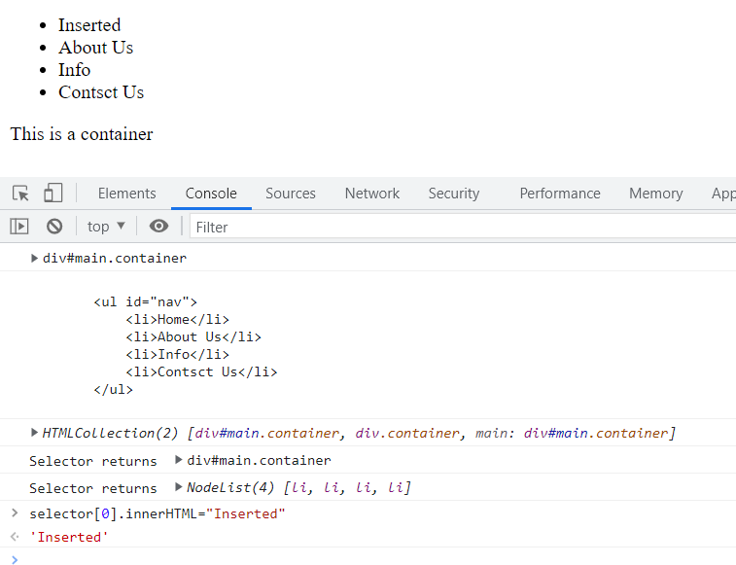

EVENTS

<!DOCTYPE html>

<html lang="en">

<head>

    <meta charset="UTF-8">

    <meta http-equiv="X-UA-Compatible" content="IE=edge">

    <meta name="viewport" content="width=device-width, initial-scale=1.0">

    <title>Js-Events</title>

    <style>

        #btn {

            background-color: blueviolet;

            color: white;

            border: 3px solid black;

            padding: 10px 14px;

            font-weight: bold;

            cursor: pointer;

        }

    </style>

</head>

<body>

    <!-- browser events : --- syntax = on_EventName = ''

    EventName can be :

    click

    contextmenu

    mouseover / mouseout

    mousedown / mouseup

    mousemove

    submit

    focus

    DOMcontentloaded -->

    <div class="container">

        <h1>This is my heading</h1>

        <p id="para">Lorem ipsum dolor sit amet consectetur adipisicing elit. Expedita quisquam cum sapiente obcaecati

            accusamus et, numquam voluptates voluptate repellendus eos sit ex, asperiores autem adipisci ipsum

            aspernatur perferendis placeat quia soluta nisi fugiat! Ut ipsa dignissimos error aut est blanditiis.</p>

    </div>

    <button id="btn" onclick="hide()">Show / Hide</button>

    <script>

        function hide() {

            let btn = document.getElementById('btn');

            let para = document.getElementById('para');

            if (para.style.display != 'none') {

                para.style.display = 'none';

            }

            else {

                para.style.display = 'block';

            }

        }

        //  Now let suppose if i want that as my mouse will be on para an alert box is shown

        let para = document.getElementById('para');

        para.addEventListener('mouseover', function run(){

            // alert("Mouse inside para !!");

            console.log("Mouse inside para !!");

        });

        para.addEventListener('mouseout', function run(){

            // alert("Mouse now outside para !!");

            console.log("Mouse now outside para !!");

        });

    </script>

</body>

</html>

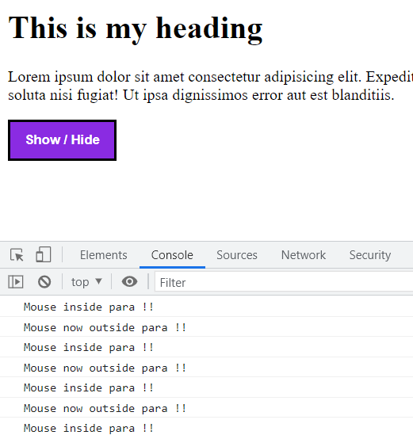

Set time ---

<!DOCTYPE html>

<html lang="en">

<head>

    <meta charset="UTF-8">

    <meta http-equiv="X-UA-Compatible" content="IE=edge">

    <meta name="viewport" content="width=device-width, initial-scale=1.0">

    <title>javaScript Settimeout SetTiemin</title>

</head>

<body>

    <div class="contaier">

        This is conatainer..

        Time now is <span id="gettime"></span>

    </div>

    <script>

        // setTimeout --> Alllows us to run the function once after the interval of time

        // clearTimeout --> Alllows us to run the function repeatedly after the interval of tim

        // SET TIME OUT

        function greet(name)

        {

            console.log("hello, good morining " + name);

        }

        // to get this greeting output after a specific time interval

        // dont give () this bracket in the function

        // 2nd argument is time in milliseconds

        // if we want to pass any argument in funciton it will be passed as a third argument

        // setTimeout(greet, 5000, "Sanskruti");

        let id = setTimeout(greet, 5000, "Sanskruti");

        // Clear Time Out

        // we will require an unique id of set time out

        console.log(id);

        clearTimeout(id);   // now no output will be shown

        // Set Interval

        // want to run greet after every 2sec

        // setInterval(greet, 2000, "Sanskruti");

        let intervalId = setInterval(greet, 2000, "Sanskruti");

        clearInterval(intervalId);

        //  to display date - time

        function display()

        {

            let time = new Date();

            // console.log(time);

            document.getElementById('gettime').innerHTML = time;

        }

        setInterval(display, 1000);

    </script>

</body>

</html>

DATE AND TIME

<!DOCTYPE html>

<html lang="en">

<head>

    <meta charset="UTF-8">

    <meta http-equiv="X-UA-Compatible" content="IE=edge">

    <meta name="viewport" content="width=device-width, initial-scale=1.0">

    <title>Date and Time</title>

</head>

<body>

    <div class="conatiner">This is a container</div>

    <script>

        // creating date in javascript

        let dt = new Date();

        console.log(dt);

        let dte = new Date(0);                // standard reference

        console.log(dte);

        let newdate = new Date("2028-04-23");

        console.log(newdate);

        // let newDate = new Date(year, month, date, hours, minutes, seconds, milliseconds);

        let newDate = new Date(3020, 4, 6, 9, 3, 2, 34);

        console.log(newDate);

        let yr = newDate.getFullYear();

        console.log("The year is ", yr);

        let dat = newDate.getDate();

        console.log("The date is ", dat);

        let month = newDate.getMonth();

        console.log("The month is ", month);

        let hr = newDate.getHours();

        console.log("The hour is ", hr);

        // it automatically corrects and shift itself

        newDate.setDate(39);

        newDate.setSeconds(29);

        console.log(newDate);

    </script>

</body>

</html>

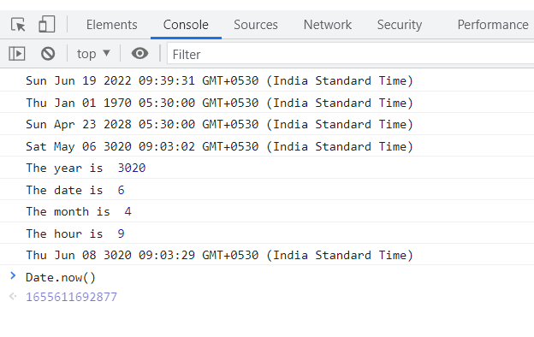

<!DOCTYPE html>

<html lang="en">

<head>

    <meta charset="UTF-8">

    <meta http-equiv="X-UA-Compatible" content="IE=edge">

    <meta name="viewport" content="width=device-width, initial-scale=1.0">

    <title>Arrow Function</title>

</head>

<body>

    <script>

        // Arrow function

        let greet = ()=> {

            console.log("Good morining");

        };

        // let greet = ()=> console.log("Good morining");

        greet();

        // let sum = (a, b)=>{

        //     return a+b;

        // };

        let sum = (a, b) => a+b;        // shortcut of the above function

        let ans = sum(3,4);

        console.log(ans);

        let half = a => a/2;

        console.log(half(4));

        let obj = {

            names : ["sanskruti", "Ram", "Rahul"],

            speak(){

                this.names.forEach(

                    (student) =>{

                        console.log("kukdooku " + student);

                });

            }

        };

        obj.speak();

    </script>

</body>

</html>

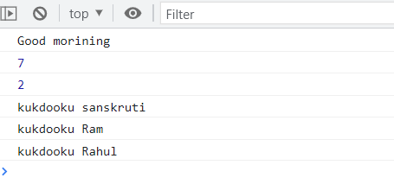

Math Obj

<!DOCTYPE html>

<html lang="en">

<head>

    <meta charset="UTF-8">

    <meta name="viewport" content="width=device-width, initial-scale=1.0">

    <meta http-equiv="X-UA-Compatible" content="ie=edge">

    <title>Math Object</title>

</head>

<body>

    <div class="container">

        <h1>This is math object tutorial</h1>

    </div>

    <script>

    // Printing the Math Object

    let m = Math;

    console.log(m)

    // Printing the constants from Math Object

    console.log("The value of Math.E is ", Math.E)

    console.log("The value of Math.PI is ", Math.PI)

    console.log("The value of Math.LN2 is ", Math.LN2)

    console.log("The value of Math.SQRT1_2 is ", Math.SQRT1_2)

    console.log("The value of Math.LOG2E is ", Math.LOG2E)

    // Printing the Functions from Math Object

    let a = 34.64534;

    let b = 89;

    console.log("The value of a and b is ", a, b);

    console.log("The value of a and b rounded is ", Math.round(a), Math.round(b));

    console.log("3 raised to the power of 2 is ", Math.pow(3, 2))

    console.log("2 raised to the power of 12 is ", Math.pow(2, 12))

    console.log("1 raised to the power of 2 is ", Math.pow(1, 2))

    console.log("Square root of 36 is ", Math.sqrt(36))

    console.log("Square root of 64 is ", Math.sqrt(64))

    console.log("Square root of 50 is ", Math.sqrt(50))

    // Ceil and floor

    console.log("5.8 rounded up to nearest integer is ", Math.ceil(5.8))

    console.log("5.8 rounded down to nearest integer is ", Math.floor(5.8))

    // Abs function

    console.log("Absolute value of 5.66 is  ", Math.abs(5.66))

    console.log("Absolute value of -5.66 is  ", Math.abs(-5.66))

    // Trinonometric Functions

    console.log("The value of sin(pi) is ", Math.sin(Math.PI/2))

    console.log("The value of tan(pi) is ", Math.tan(Math.PI/2))

    console.log("The value of cos(pi) is ", Math.cos(Math.PI/2))

    // Min and max functions

    console.log("Minimum value of 4, 5, 6 is ", Math.min(4,5, 6));

    console.log("Minimum value of 14, 5, 16 is ", Math.min(14,5, 16));

    console.log("Maximum value of 4, 5, 6 is ", Math.max(4,5, 6));

    console.log("Maximum value of 14, 5, 16 is ", Math.max(14,5, 16));

    // Generating a random number

    let r = Math.random();

    // Random number b/w (a, b) = a + (b-a)*Math.random()

    let a1 = 50;

    let b1 = 60;

    let r50_60 = a1 + (b1-a1)*Math.random();

    console.log("The random number is ", r)

    console.log("The random number is ", r50_60)

    </script>

</body>

</html>

